SlvaTech-
LIDAR BASED TREE DETECTION AND CLIMATE ANALYSIS SYSTEM
A Report
Submitted in partial fulfilment of the Requirements for the completion of
THEME BASED PROJECT

BACHELOR OF ENGINEERING
IN

INFORMATION TECHNOLOGY
By

G.AKSHITHA 1602-23-737-132

J.SHIFFRA 1602-23-737-146

U.KARTHIKA 1602-23-737-149

Under the guidance of


HITENDRA SARMA

DESIGNATION – ASSOCIATE PROFESSOR
Department of Information Technology
Vasavi College of Engineering (Autonomous)
ACCREDITED BY NAAC WITH 'A++' GRADE.
(Affiliated to Osmania University and Approved by AICTE)
2026
Vasavi College of Engineering (Autonomous)
ACCREDITED BY NAAC WITH 'A++' GRADE
(Affiliated to Osmania University and Approved by AICTE)
Ibrahim Bagh, Hyderabad-31
Department of Information Technology

DECLARATION BY CANDIDATES
We, G.Akshitha, J.Shiffra,U.Karthika bearing hall ticket number, 1602-23-737-132, 1602-23-737-146, 1602-23-737-149, hereby declare that the project report entitled " SlyvaTech-LiDAR Based Tree Detection and Climate Analysis System" under the guidance of Hitendar Sarma, Associate Professor, Department of Information Technology, Vasavi College of Engineering, Hyderabad, is submitted in partial fulfillment of the requirement for the completion of Theme-based project, VI semester, Bachelor of Engineering in Information Technology.
This is a record of bonafide work carried out by us and the results embodied in this project report have not been submitted to any other institutes.
G.Akshitha(1602-23-737-132), J.Shiffra (1602-23-737-146), U.Kathika (1602-23-737-149)

Vasavi College of Engineering (Autonomous)
ACCREDITED BY NAAC WITH 'A++' GRADE
(Affiliated to Osmania University and Approved by AICTE)
Ibrahim Bagh, Hyderabad-31
Department of Information Technology

BONAFIDE CERTIFICATE
This is to certify that the project entitled " SlvaTech-LiDAR Based Tree Detection and Climate Analysis System" being submitted by G.Akshitha, J. Shiffra, U.Karthika bearing 1602-23-737-132, 1602-23-737-146, 1602-23-737-149, in partial fulfillment of the requirements for the completion of Theme-based project of Bachelor of Engineering in Information Technology is a record of bonafide work carried out by them under my guidance.
GUIDE NAME- HITENDAR SARMA | External Examiner | Dr. K. Ram Mohan Rao
Designation Associate professor |  | Professor, HOD IT

ABSTRACT
The LiDAR Based Tree Analysis and Climate Monitoring System is an advanced geospatial analysis platform designed to process and interpret LiDAR (Light Detection and Ranging) data for environmental monitoring and forest assessment. The system aims to automate the detection, segmentation, and analysis of individual trees using high-resolution point cloud data.
The platform takes raw LiDAR data in .las or .laz formats and converts it into structured raster representations such as Digital Surface Models (DSM) and Canopy Height Models (CHM). These representations enable effective extraction of vegetation features by distinguishing ground elevation from canopy height. A deep learning-based U-Net architecture is employed to perform semantic segmentation on the processed data, identifying regions corresponding to tree canopies.
Following segmentation, advanced image processing techniques such as peak detection and watershed segmentation are applied to separate individual trees from clustered vegetation regions. The system further computes important ecological parameters such as tree height, canopy width, and approximate biomass, which are critical for climate monitoring and carbon estimation studies.
The backend of the system is developed using FastAPI, which handles LiDAR file processing, model inference, and feature extraction. The frontend is implemented using React and Three.js, enabling interactive 3D visualization of LiDAR point clouds and detected trees. The system follows a modular client-server architecture, ensuring scalability and efficient data processing.
This report presents the complete system design, implementation methodology, experimental results, and future enhancements of the LiDAR-based tree analysis system.

TABLE OF CONTENTS
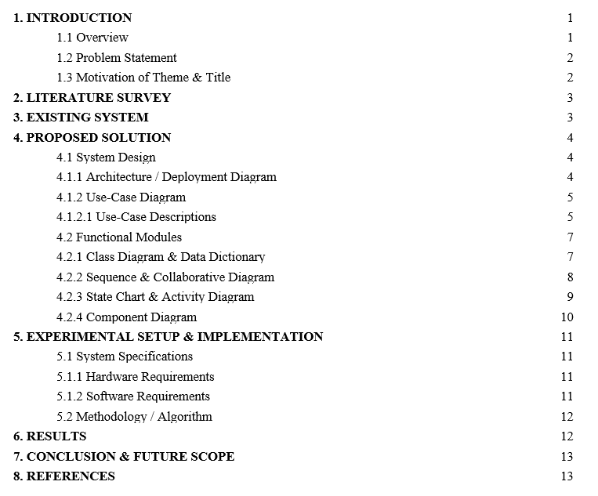

LIST OF FIGURES
Figure 1: Use Case Diagram
Figure 2: Class Diagram
Figure 3: Sequence Diagram
Figure 4: Collaborative Diagram
Figure 5: State Chart Diagram
Figure 6: Activity Diagram
Figure 7: Component Diagram
Figure 8: Deployment Diagram
LIST OF TABLES
Table 1: Data Dictionary
LIST OF ABBREVIATIONS
LiDAR – Light Detection and Ranging
DSM – Digital Surface Model
DTM – Digital Terrain Model
nDSM – Normalized DSM
U-Net – Deep learning segmentation modelAPI - Application Programming Interface
SRS - Software Requirements Specification
HOD - Head of Department

1. INTRODUCTION
1.1 Overview
LiDAR (Light Detection and Ranging) is a remote sensing technology that uses laser pulses to measure distances and generate precise three-dimensional information about the Earth's surface. It has become an essential tool in forestry, environmental monitoring, and geographic information systems (GIS).
The proposed LiDAR Based Tree Analysis System utilizes this technology to analyze forest structures by detecting individual trees and estimating their physical characteristics. The system processes raw LiDAR point cloud data and converts it into structured representations that can be analyzed using machine learning techniques.
By integrating deep learning models with traditional image processing algorithms, the system provides an automated solution for tree detection and analysis. Additionally, the platform includes a visualization module that allows users to explore the forest data interactively in a 3D environment.

1.2 Problem Statement
Forest monitoring and tree analysis are critical for understanding ecological balance, carbon sequestration, and climate change. Traditional methods of tree counting and measurement rely heavily on manual field surveys, which are time-consuming, labor-intensive, and prone to human error.
Although LiDAR technology provides high-resolution data, extracting meaningful insights such as tree count, height, and canopy structure requires complex processing techniques. Existing systems often lack automation, scalability, and user-friendly visualization capabilities.
Therefore, there is a need for an intelligent system that can efficiently process LiDAR data, accurately detect trees, and provide meaningful environmental insights in a scalable and automated manner.

1.3 Motivation of Theme & Title
The motivation behind this project stems from the increasing need for sustainable environmental monitoring and climate analysis. Forests play a vital role in maintaining ecological balance, and accurate information about tree distribution and biomass is essential for climate research.
By leveraging LiDAR data and deep learning techniques, this project aims to provide an efficient and automated solution for forest analysis. The integration of visualization tools further enhances the usability of the system, making it accessible to researchers and environmental analysts.
2. LITERATURE SURVEY
Several research studies have explored the use of LiDAR data for forest analysis and tree detection. LiDAR-based canopy height models (CHM) have been widely used to identify vegetation structures and estimate tree heights. Studies have shown that local maxima detection techniques are effective in identifying individual tree tops in forested regions.
Deep learning models, particularly convolutional neural networks (CNNs) and U-Net architectures, have demonstrated high accuracy in image segmentation tasks. These models are capable of learning complex spatial patterns, making them suitable for identifying tree regions in rasterized LiDAR data.
Watershed segmentation is another widely used technique for separating overlapping objects in image processing. In the context of forest analysis, it is used to divide clustered tree regions into individual trees based on detected peaks.
Existing systems often combine these techniques to improve accuracy. However, challenges such as overlapping canopies, varying terrain, and noise in LiDAR data still persist. The proposed system builds upon these techniques to create a more integrated and user-friendly solution.

3. EXISTING SYSTEM
Current forest analysis systems rely on a combination of remote sensing tools and manual interpretation. While LiDAR data provides high-resolution information, processing it requires specialized tools and expertise.
Many existing systems lack automation and require manual intervention for tree detection and analysis. Additionally, they often do not provide real-time visualization or interactive exploration capabilities.
Limitations of existing systems include:
- Lack of automated tree detection
- Difficulty in separating overlapping canopies
- Limited visualization capabilities
- High computational complexity

4. PROPOSED SOLUTION
The proposed system provides an end-to-end solution for LiDAR data processing, tree detection, and visualization. It integrates multiple techniques to achieve accurate and efficient results.
The system converts raw LiDAR data into structured formats, applies deep learning for segmentation, and uses watershed algorithms for tree separation. It also computes key features such as tree height and biomass.

4.1 System Design

4.1.1 Architecture / Deployment Diagram
The deployment architecture of the LiDAR Based Tree Detection and Climate Analysis System consists of a client device running a web browser, a backend server hosting the core processing modules (LiDAR Preprocessing, U-Net Segmentation, Peak Detection, Watershed Segmentation, and Feature Extraction), and a storage layer that maintains LiDAR datasets and processed outputs.
The frontend application is developed using React and Three.js, which enables users to upload LiDAR files and visualize the processed results in an interactive 3D environment. The backend is implemented using FastAPI, which handles file processing, model inference, and feature extraction.
The system processes LiDAR point cloud data to generate DSM and nDSM representations, which are then used for segmentation and tree detection. Communication between the client and server is carried out using HTTP protocols, while the backend interacts with storage systems for data retrieval and storage.
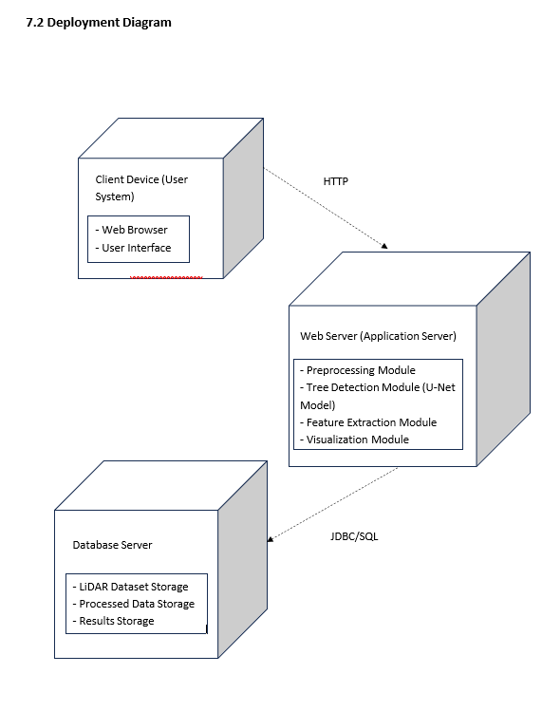
Figure 8: Deployment Diagram - LIDAR System Architecture

4.1.2 Use-Case Diagram
The use case diagram for the LiDAR system represents interactions between the primary actors (User, Admin, Data Source, and Visualization System) and the system functionalities.
Users interact with the system to upload LiDAR files, initiate processing, detect trees, and visualize results. The Admin manages system configuration, model training, and performance monitoring. The Data Source provides LiDAR datasets, and the Visualization System renders processed outputs in 3D.

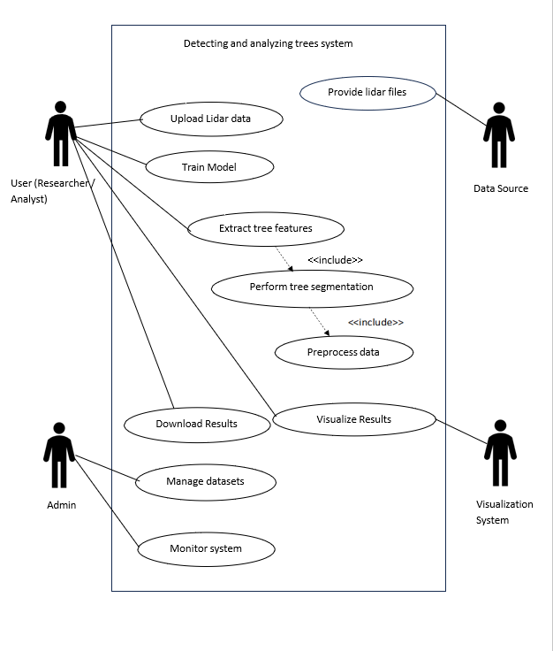
Figure 1: Use Case Diagram
4.1.2.1 Use-Case Descriptions
UC-001: Upload LiDAR Data
Use Case ID | UC-001
Use Case Name | Upload LiDAR Data
Actor(s) | User
Precondition | User must have a valid LiDAR file (.las/.laz format)
Main Flow | User opens upload interface → System prompts file selection → User selects LiDAR file → System validates file → File is uploaded to backend → System confirms upload
Alternative Flow | User uploads invalid file → System rejects file
Exception Flow | Upload failure → Error message displayed
Postcondition | LiDAR file is successfully stored
UC-002: Preprocess LiDAR Data
Use Case ID | UC-002
Use Case Name | Preprocess LiDAR Data
Actor(s) | System
Precondition | LiDAR file must be uploaded
Main Flow | System reads LiDAR data → Noise removal → DSM generation → DTM estimation → nDSM computation → Data normalization
Alternative Flow | Missing data → Interpolation applied
Exception Flow | Processing failure → Error logged
Postcondition | Data ready for segmentation

UC-003: Perform Tree Segmentation
Use Case ID | UC-003
Use Case Name | Perform Tree Segmentation
Actor(s) | System
Precondition | nDSM must be available
Main Flow | Load U-Net model → Input nDSM → Generate probability map → Thresholding → Binary mask creation → Store segmentation
Alternative Flow | Low confidence → Threshold adjusted
Exception Flow | Model failure → Processing stopped
Postcondition | Tree regions identified
UC-004: Detect Individual Trees
Use Case ID | UC-004
Use Case Name | Detect Individual Trees
Actor(s) | System
Precondition | Segmentation mask must exist
Main Flow | Peak detection → Identify tree tops → Assign markers → Apply watershed → Separate tree regions
Alternative Flow | Dense canopy → Adjust peak detection parameters
Exception Flow | No peaks detected → Empty result returned
Postcondition | Individual trees detected

UC-005: Extract Tree Features
Use Case ID | UC-005
Use Case Name | Extract Tree Features
Actor(s) | System
Precondition | Tree regions must be available
Main Flow | Calculate height → Estimate canopy width → Compute biomass → Store tree attributes
Alternative Flow | Missing values → Approximation used
Exception Flow | Calculation failure → Skip region
Postcondition | Tree features extracted

UC-006: Visualize Results
Use Case ID | UC-006
Use Case Name | Visualize Results
Actor(s) | User
Precondition | Tree detection must be completed
Main Flow | Load processed data → Render 3D point cloud → Display tree markers → Show statistics
Alternative Flow | Large dataset → Apply sampling
Exception Flow | Rendering failure → Reload viewer
Postcondition | User visualizes forest structure

4.2 Functional Modules
4.2.1 Class Diagram & Data Dictionary
The class diagram defines key entities such as User, LiDARData, Preprocessor, SegmentationModel, TreeDetector, FeatureExtractor, and VisualizationModule.
The LiDARData class stores point cloud data, while the Preprocessor converts it into structured formats such as DSM and nDSM. The SegmentationModel applies U-Net for identifying tree regions. The TreeDetector uses peak detection and watershed algorithms to separate individual trees. The FeatureExtractor computes tree attributes, and the VisualizationModule renders results in 3D.
1
1
1
+ monitorSystem()
+ manageDataset()
1
+ render3D()
+ render2D()
+ displayResults()
+ extractFeatures()
+ calculateHeight()
+ calculateCanopy()
+ filterNoise()
+ generateDSM()
+ generateDTM()
+ computeNDSM()
- viewType : String
- renderStatus : String
- processId : int
- status : String
- featureId : int
- treeHeight : float
- canopyArea : float
Preprocessor
Visualization
TreeFeatureExtractor
+ validateData()
+ storeData()
1..*
1
1
1
1
1..*
1
1
1..*
+ uploadData()
+ viewResults()
- minId : int
- dataId : int
- fileName : String
- fileType : String
Admin
- userId : int
- name : String
User
LiDARData
1
Figure 2: Class Diagram – LiDAR System

Data Dictionary
Field | Type | Description
file_id | UUID | Unique identifier for LiDAR file
x | Float | X coordinate
y | Float | Y coordinate
z | Float | Height value
ndsm_value | Float | Height above ground
tree_id | UUID | Unique tree identifier
height | Float | Tree height
canopy_width | Float | Tree canopy size
biomass | Float | Estimated biomass
point_cloud | Array | LiDAR points
segmentation_mask | Array | Binary mask
prediction_score | Float | Model confidence
Table 1: Data Dictionary

4.2.2 Sequence Diagram & Collaborative Diagram
The sequence diagram illustrates the interaction flow when a user uploads a LiDAR file. The request is sent to the backend, where preprocessing is performed. The processed data is passed to the U-Net model for segmentation. The output is then processed using peak detection and watershed algorithms to detect trees. Finally, the results are sent back to the frontend for visualization.
The collaborative diagram represents the same interaction in terms of object relationships between frontend, backend, model, and visualization modules.

5.Behavioral View
5.1Sequence Diagram:

User
UI
LiDARData
Preprocessor
TreeFeatureExtractor
Visualization

Upload data
Validate data
Validation success

Start processing Preprocessing data

Preprocess complete

Extract features

Features extracted

User

1.uploadData() 16.showResults()
- filterNoise()


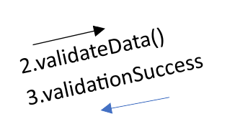
- generateDSM()
10. extractFeatures()
Visualization
UI
15. visualizationReady
4.preprocessData()
Preprocessor
LiDARData
- generateDTM() 8.computeNDSM()

TreeFeatureExtractor
11.calculateHeight()
12.calculateCanopy()
Figure 3 & 4: Sequence and Collaborative Diagrams

4.2.3 State Chart Diagram & Activity Diagram
The state chart diagram represents the lifecycle of LiDAR data processing, starting from file upload, preprocessing, segmentation, tree detection, feature extraction, and visualization. The system transitions between these states until the final output is displayed.
The activity diagram shows the workflow of the system, including parallel processing of segmentation and feature extraction before merging into visualization.
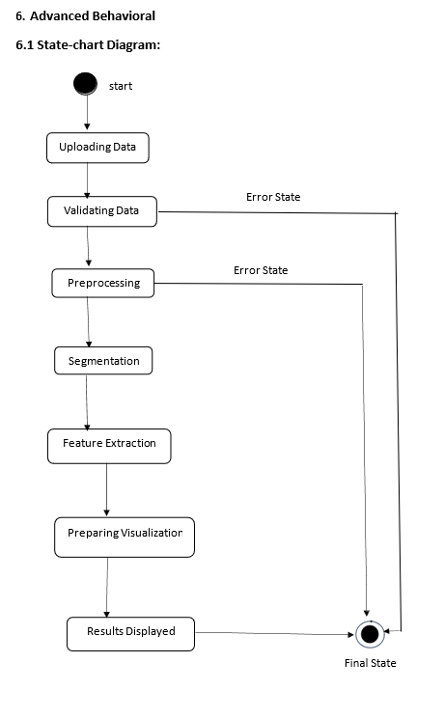
Figure 5: State Chart Diagram

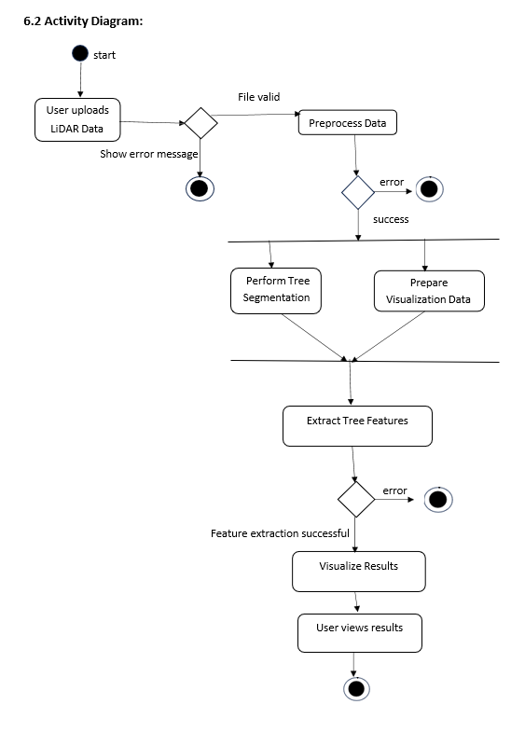
Figure 6: Activity Diagram

4.2.4 Component Diagram
The component diagram represents major system components including:
- User Interface (React)
- Backend Server (FastAPI)
- LiDAR Processing Module
- U-Net Model
- Tree Detection Module
- Visualization Module (Three.js)
These components interact through defined APIs to ensure modularity and scalability.
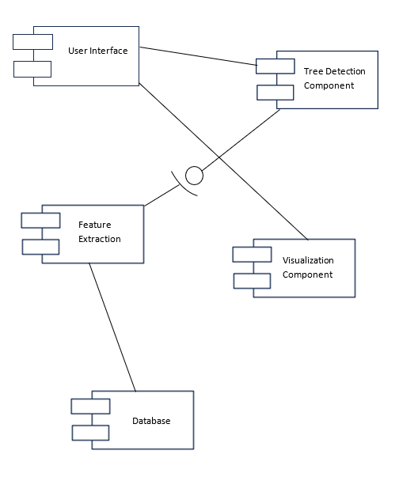
Figure 7: Component Diagram

5. EXPERIMENTAL SETUP & IMPLEMENTATION
5.1 System Specifications
5.1.1 Hardware Requirements
• Processor: Intel Core i3 or equivalent (minimum)
• RAM: 4 GB minimum (8 GB recommended for faster LiDAR processing)
• Storage: 20 GB free disk space (for LiDAR datasets and outputs)
• Network: Stable internet connection (for frontend-backend communication)
• Display: 1280 x 720 resolution or higher
5.1.2 Software Requirements
• Operating System: Windows 10 / Ubuntu 20.04 or higher
• Backend: Python 3.10+, FastAPI framework
• Database: File-based storage (LiDAR .las/.laz files) or optional SQLite/PostgreSQL
• AI Module: Python 3.10+, PyTorch, NumPy, OpenCV, scikit-image
• LiDAR Processing Libraries: laspy, Open3D, SciPy
• Frontend: HTML5, CSS3, JavaScript (React.js, Three.js)
• Visualization Engine: Three.js / React Three Fiber
• Version Control: Git / GitHub
• Browser: Google Chrome / Mozilla Firefox (latest version)

5.2 Methodology / Algorithm
The methodology involves multiple stages of data processing and analysis.
Initially, raw LiDAR data is read and preprocessed to remove noise and normalize coordinates. The processed data is then converted into raster formats such as DSM and CHM.
The CHM is used as input to a trained U-Net model, which performs segmentation to identify tree regions. The output of the model is a probability map indicating the likelihood of each pixel belonging to a tree.
This probability map is converted into a binary mask using thresholding techniques. Morphological operations are applied to remove noise and refine the segmentation.
Peak detection is then performed to identify tree tops, followed by watershed segmentation to separate individual trees. Finally, tree features such as height, canopy width, and biomass are computed.

6. RESULTS
The system successfully processes LiDAR datasets and produces accurate tree detection results. The segmentation model effectively identifies tree regions, and the watershed algorithm successfully separates overlapping trees.
The system provides interactive 3D visualization of the point cloud, allowing users to explore the forest structure. Tree markers are displayed at detected locations, and statistical metrics such as tree count and average height are calculated.
The results demonstrate the effectiveness of combining deep learning with traditional image processing techniques for forest analysis.
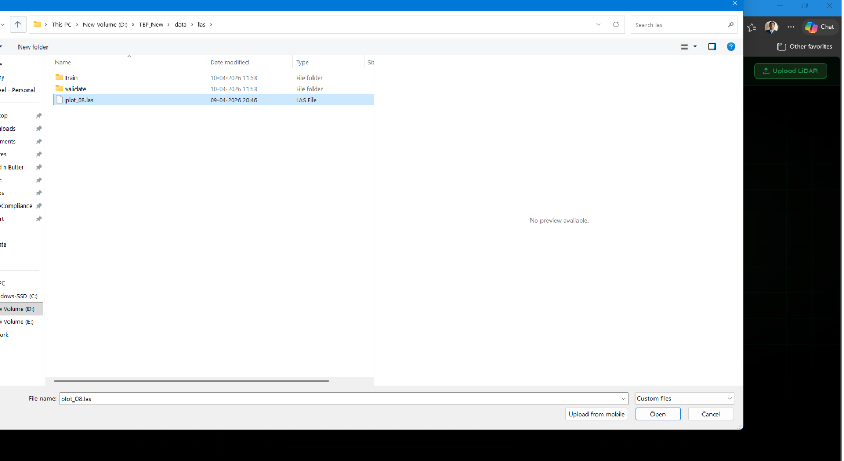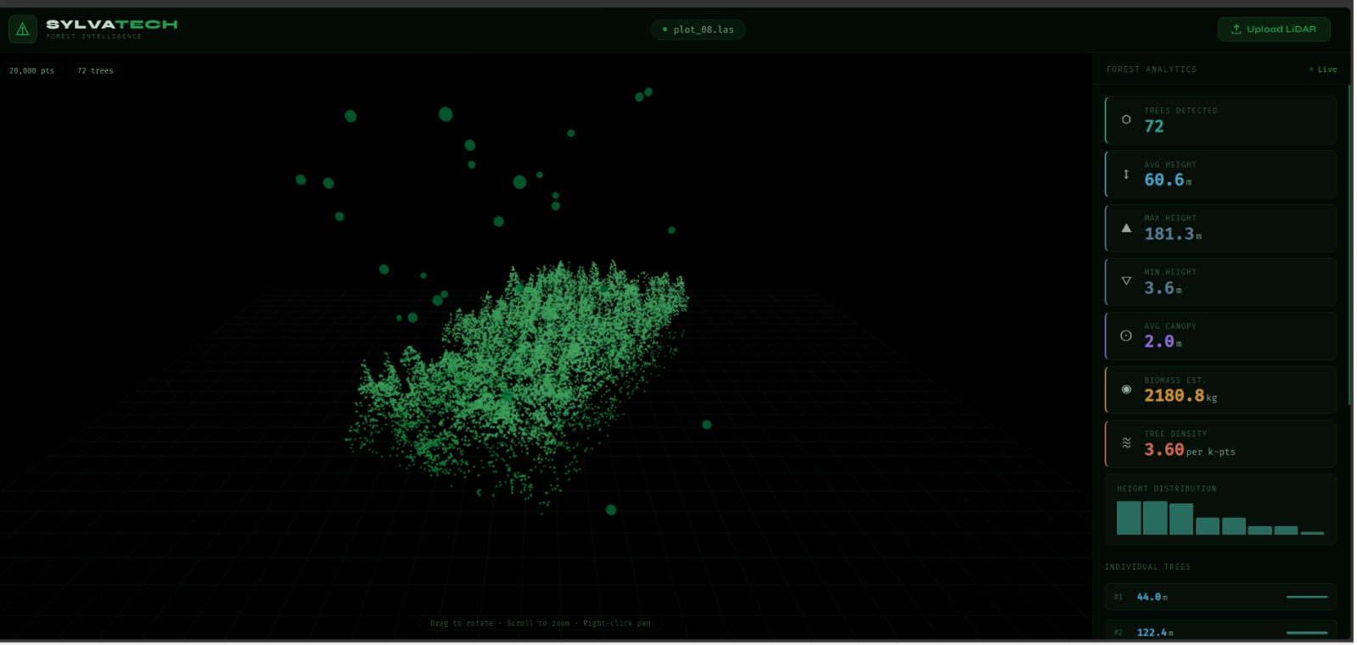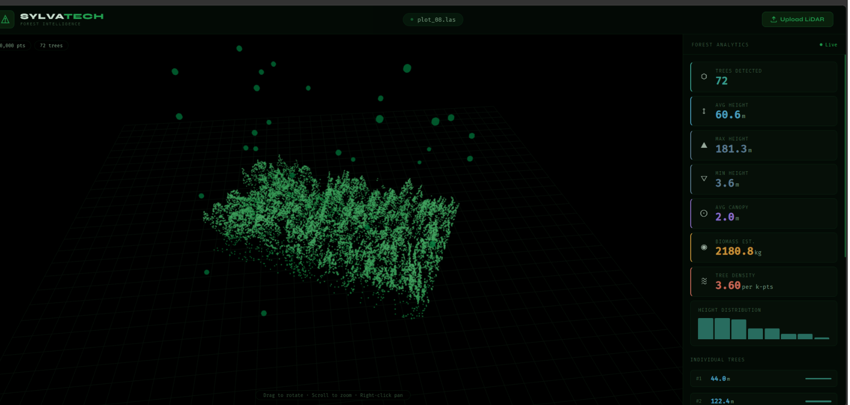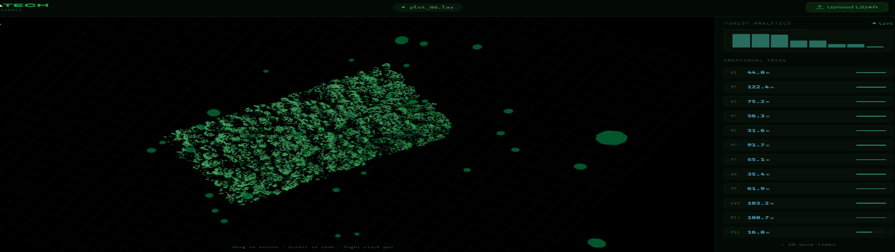

7.CONCLUSION & FUTURE SCOPE
The LiDAR Based Tree Detection and Climate Analysis System successfully delivers an intelligent platform for analyzing forest structures using LiDAR data. By combining LiDAR preprocessing, deep learning-based segmentation, peak detection, and watershed algorithms, the system provides an automated solution for detecting individual trees and estimating their structural attributes such as height, canopy width, and biomass. The integration of a 3D visualization interface further enhances the system by allowing users to interactively explore forest data. The modular architecture of the system ensures scalability, flexibility, and efficient processing of large LiDAR datasets.
Future scope includes: (1) Integration of advanced deep learning models to improve segmentation accuracy in dense forest regions; (2) Implementation of more accurate biomass and carbon estimation models for environmental analysis; (3) Support for real-time LiDAR data processing using streaming techniques; (4) Development of mobile and web-based applications for wider accessibility; (5) Integration with climate monitoring systems and geographic information systems (GIS) for enhanced analysis; and (6) incorporation of additional environmental parameters such as soil data and weather conditions to improve prediction capabilities.

8. REFERENCES

[1] IEEE Standard for Software Requirements Specifications (IEEE Std 830-1998). IEEE Computer Society.
[2] Popescu, S. C., & Wynne, R. H. (2004). Seeing the trees in the forest: Using LiDAR and multispectral data fusion with local filtering and variable window size for estimating tree height. Photogrammetric Engineering & Remote Sensing.
[3] Ronneberger, O., Fischer, P., & Brox, T. (2015). U-Net: Convolutional Networks for Biomedical Image Segmentation. Springer.
[4] Vincent, L., & Soille, P. (1991). Watersheds in digital spaces: An efficient algorithm based on immersion simulations. IEEE Transactions on Pattern Analysis and Machine Intelligence.
[5] PyTorch Documentation. Available: https://pytorch.org/docs/
[6] FastAPI Documentation. Available: https://fastapi.tiangolo.com/
[7] Three.js Documentation. Available: https://threejs.org/docs/
[8] GitHub link: https://github.com/ShiffraJay/SlyvaTech_LiDAR-Forest-Analysis/

9.CODE APPENDIX
Server.py